Institute for Software Integrated Systems
Vanderbilt University
Nashville
Tennessee, 37203

TECHNICAL REPORT

TR#: ISIS-06-705

Title: Compositional Specification of Behavioral Semantics

Author: Kai Chen, Janos Sztipanovits, Sandeep Neema

Abstract
Domain-Specific Modeling Languages (DSMLs) play fundamental role in the model-based design of embedded software and systems. While abstract syntax metamodeling enables the rapid and inexpensive development of DSMLs, the specification of DSML semantics is still a hard problem. In previous work, we have developed methods and tools for the semantic anchoring of DSMLs. Semantic anchoring introduces a set of reusable “semantic units” that provide reference semantics for basic behavioral categories using the Abstract State Machine framework. In this paper, we extend the semantic anchoring framework to heterogeneous behaviors by developing method for the composition of semantic units. Semantic unit composition reduces the required effort from DSML designers and improves the quality of the specification. The proposed method is demonstrated through a case study.

Table of Contents
1. Introduction 4
2. Background: Semantic Anchoring 6
3. Compositional Specification of Semantics 8
4. SEFSM Overview 10
5. Primary Semantic Units Used 14
5.1 Specification of FSM-SU 14
5.2 Specification of SDF-SU 16
6. Compositional Semantics Specification for SEFSM Components 19
6.1 Structural Composition 19
6.2 Behavioral Composition 20
7. Compositional Semantics Specification for SEFSM Systems 24
7.1 Structural Composition 24
7.2 Behavioral Composition 25
8. Conclusion 27
References 28

Introduction
Model-based design of embedded software uses formal, composable and manipulable models in the design, implementation and system integration process. Modeling languages introduce layers of abstractions in the design flow - a central concept of platform-based design [9] - that are synergistic with the design objectives and the nature of the system to be designed. An emerging common trend in model-based software and systems design is that modeling languages are domain-specific: they offer software/system developers abstractions and notations that are tailored to characteristics of their application domain. Domain-Specific Modeling Languages (DSMLs) are designed to express structural and behavioral aspects of systems that are essential in the design process.
Model analysis and model-based code generation require the precise specification of DSMLs. This is partly achieved by metamodeling languages and metamodels describing the abstract syntax (concepts, relationships and well-formedness rules) of DSMLs [8]. While abstract syntax metamodeling has been an important step in model-based design and been used in various model-based design frameworks, such as Eclipse [1] and Software Factories [2], explicit and formal specification of behavioral semantics has not received much attention. For instance, the SPT profile [3] (UML Profile for Schedulability, Performance and Time) does not have precisely defined semantics [4], which creates possibility for semantic mismatch between design models and modeling languages of analysis tools. This is particularly problematic in safety critical real-time and embedded systems domain, where semantic ambiguities may produce conflicting results across different tools.
There have been several important results in defining semantics for specific modeling languages like the Hybrid System Interchange Format (HSIF) by means of informal mathematical text [5], or UML state machines using formal mathematical frameworks, such as Abstract State Machines [6] [7]. However, the central role of DSMLs in embedded software and systems brings in additional challenges due to the following characteristics of model-based design flows:
- Heterogeneity of tool chains. Tool chains supporting domain-specific design flows integrate modeling, analysis and synthesis tools using DSMLs with overlapping semantics. Explicit representation of their semantics is only a necessary but not sufficient condition for integratability. Designers need to understand precisely the relationship between the semantics (see e.g. Timed Automata [10]) to establish consistent design flows.
- Heterogeneity of systems. Embedded systems are composed from heterogeneous components using heterogeneous interaction mechanisms. Modeling and understanding heterogeneous systems is a significant challenge [11]. Since DSMLs are designed for modeling heterogeneous systems, the specification of their semantics must address these challenges.
- Validation and verification. Specification of behavioral semantics of DSMLs is not only an exercise in mathematical precision but has practical significance. DSML designers need to validate behavioral semantics via inspecting traces generated by test models. Similarly, semantic accuracy of simulators and code generators must be tested via comparing their behavior with behaviors generated by the “reference semantics”.
We started addressing these problems by extending our Model Integrated Computing (MIC) tool suite [12] with an infrastructure for semantic anchoring of DSMLs. The Semantic Anchoring infrastructure [13] includes a set of well-defined “semantic units” that capture the operational semantics of basic dynamic behavior categories and Models of Computations using Abstract State Machines [7] as an underlying formal framework and the Abstract State Machine Language (AsmL) tool suite [15]. The semantics of a DSML is defined by specifying the transformation between the abstract syntax metamodel of the DSML and that of a selected semantic unit [14]. We have discussed the development of semantic units for complex behaviors such as timed automata [10] and showed the use of the semantic anchoring process by presenting anchoring rules for the UPPAAL [16] and IF [17] languages. In this paper we build on these results and address the impact of system heterogeneity by developing a method for the compositional specification of semantic units.
The organization of this report is the following: Section 2 provides a short overview of the concepts of semantic units and semantic anchoring. We describe the core idea for composition in Section 3. In Section 4, 5, 6 and 7 we develop compositional specification for the semantics of a complex modeling language EFSM (Extended Finite State Machine) proposed for industrial (automotive) applications elsewhere [18]. Section 8 is our conclusion.

Background: Semantic Anchoring
A DSML is formally defined as a 5-tuple L = <A, C, S, M_{S}, M_{C}> consisting of abstract syntax (A), concrete syntax (C), syntactic mapping (M_{C}), semantic domain (S) and semantic mapping (M_{S}) [8]. The abstract syntax A defines the language concepts, their relationships, and well-formedness rules available in the language. The concrete syntax C defines the specific notations used to express models, which may be graphical, textual, or mixed. The syntactic mapping, M_{C}: C→A, assigns syntactic constructs to elements in the abstract syntax. The DSML semantics are defined in two parts: a semantic domain S and a semantic mapping M_{S}: A→S. The semantic domain S is usually defined in some formal, mathematical framework, in terms of which the meaning of the models is explained. The semantic mapping relates syntactic concepts to those of the semantic domain.
Although DSMLs use many different modeling concepts and notations for accommodating needs of domains and user communities, the scope of well understood behavioral abstractions are more limited. Broad categories of component behaviors can be represented by a finite set of basic behavioral categories, such as Finite State Machine (FSM), Timed Automaton (TA) and Hybrid Automaton (HA). Similarly, analyzability requirements and the need for correct-by-construction system composition have led to the emergence of basic component interaction categories expressed as Model of Computations such as Synchronous Data Flow (SDF), Communicating Sequential Process (CSP) and Process Networks (PN) [11]. This observation led us to propose a semantic anchoring infrastructure for defining behavioral semantics for DSMLs. The development and use of the semantic anchoring infrastructure includes the following tasks [13]:
- Definition of a set of modeling languages {L_{i}} for capturing semantics of the basic behavioral abstractions and development of the precise specifications for all components of L_{i} = <C_{i}, A_{i}, S_{i}, M_{Si}, M_{Ci}>. We use the term semantic units to describe these basic modeling languages.
- Definition of the behavioral semantics of an arbitrary L = <C, A, S, M_{S}, M_{C}> DSML is accomplished by specifying the M_{A}: A → A_{i} mapping to a predefined semantic unit L_{i}. The M_{S}: A → S semantic mapping of L is then defined by the composition M_{S} = M_{Si} ○ M_{A}, which indicates that the semantics of L is anchored to the S_{i} semantic domain of the L_{i} modeling language.
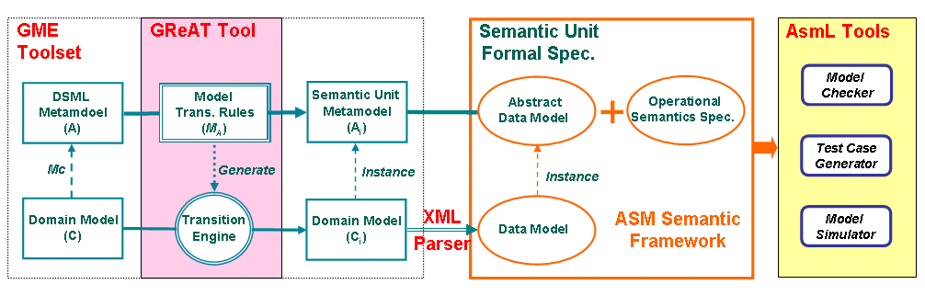
Figure 1: Semantic Anchoring tool suite for DSML design
Figure 1 shows our semantic anchoring tool suite. It comprises (1) the ASM-based AsmL tool suite [15] from Microsoft Research for specifying semantic units and (2) the MIC modeling (GME) [18] and model transformation (GReAT) [19] tool suites that support the specification of transformation between the DSML metamodels and the Abstract Data Models used in the semantic units. (Readers can refer [20] for more details.) The operational semantics of semantic units are specified as a Control State ASMs [7]. Mathematically, a semantic unit specification is represented as a tuple <A, R>, where A is an Abstract Data Model that specifies the abstract syntax of the semantic unit and R that represents a set of Operations and Transition Rules (updates, in ASM terminology), which specify the behavior of each m ∈ M. We use M = Ι (A) to denote the set of all instances of A, where m ∈ M are the syntactically correct (well formed) Data Models defined by the abstract syntax. The behavior in ASMs is modeled by a sequence of steps (or runs), where a Step in a given state includes the execution simultaneously of all Rules whose guard conditions are true (and the updates are consistent) [7]. Since ASM states are mathematical structures (sets with basic operations and predicates), it is easy to integrate Abstract Data Models and Rules. The integrated tool suite ensures that behavior of domain models defined in a DSML is simulated according to their “reference semantics” by automatically transforming them into AsmL data models using the transformation rules. In the following Sections we document the specifications in AsmL for the sake of readability.

Compositional Specification of Semantics
In the semantic anchoring infrastructure, we define a finite set of semantic units, which capture the semantics of basic behavioral and interaction categories. If the semantics of a DSML can be directly mapped onto one of these basic categories, its semantics can be defined by simply specifying the model transformation rules between the DSML and the Abstract Data Model of the semantic unit [14]. However, in heterogeneous systems, the semantics is not always fully captured by a predefined semantic unit. If the semantics is specified from scratch (which is the typical solution if it is done at all) it is not only expensive but we loose the advantages of anchoring the semantics to (a set of) common and well-established semantic units. This is not only loosing reusability of previous efforts, but has negative consequences on our ability to relate semantics of DSMLs to each other and to guide language designers to use well understood and safe behavioral and interaction semantic “building blocks” as well.
Our proposed solution is to define semantics for heterogeneous DSMLs compositionally. If the composed semantics specifies a behavior which is frequently used in system design, (for example composition of SDF interaction semantics with FSM behavioral semantics defines semantics for modeling signal processing systems [11]) the resulting semantics can be considered a derived semantic unit, which is built on primary semantic units, and could be offered up as one of the set of semantic units for future anchoring efforts. The composition method we describe in the rest of the paper is strongly influenced by Gossler and Sifakis framework for composition [21] and has commonalities with composition approaches used in Ptolemy [11] and Metropolis [22] by clearly separating behavior and interaction. In the following we provide a brief overview of the composition approach that will be followed by a detailed case study.
Mathematically, a composed semantics is represented as a tuple CS = <A, R>. Similarly to [21], we model semantic unit composition as structural and behavioral compositions (see Figure 2). In the Figure, we represented ASM instances that include an m data model, the R rule set and the S dynamic state variables updated during runs. The structural composition defines relationships among selected elements of Abstract Data Models using partial maps. In Figure 2, we demonstrate semantic composition with two semantic units, SU1 and SU2. The structural composition yields the composed Abstract Data Model A = <A_{C}, A_{SU1}, A_{SU2}, g₁, g₂ >, where g₁, g₂ are the partial maps between concepts in A_{C}, A_{SU1}, and A_{SU2}.
Behavioral composition is completed by the R_{C} set of rules that together with R_{SU1} and R_{SU2} form the R rule set for the composed semantics. The role of the R_{C} set of rules is to receive the possible sets of actions that can be offered by the embedded semantic units using the Get(…) calls, to restrict these sets according to the interactions created by the structural composition and to send back selected subset of actions through the Run(…) call to complete their next step. The executable actions are represented as partial orders above the set of actions. (This will be shown in detail in the following Sections.)
Figure 2: A graphical representation for the semantic unit composition
Remark: The behavioral composition specifies a controller, which restricts the executions of actions. Since the behavior of the embedded semantic units can be described as partial orders on the sets of actions they can perform, the behavioral composition can be modeled mathematically as a composition of the partial orders.
In the rest of this paper, we first describe a simplified version of EFSM, called SEFSM, which only includes the modeling constructs that determine the core behavioral semantics of EFSM. Then, we apply structural and behavioral composition for two primary semantic units, Finite State Machine (FSM-SU) and Synchronous Dataflow (SDF-SU), to define the semantics of SEFSM. As the first step in the composition sequence, we define semantics for Action Automata (AA). We use the semantics of AA as a new derived semantic unit (AA-SU) that we further compose with SDF-SU to SEFSM as the composition of individual components whose semantics are defined by obtaining the semantics for EFSM. Due to space limitations, we need to omit many details of the specification. The full semantics specifications can be downloaded from [20].

SEFSM Overview
EFSM has been developed by General Motors Research to specify vehicle motion control (VMC) software [23]. In order to satisfy the requirements of the VMC domain, EFSM provides a narrow and precisely-defined set of modeling constructs that can represent concurrent FSMs, mathematical functions, data types, physical units, value ranges, and a hierarchical signal and event type structure. Because the semantic anchoring methodology focuses on the behavioral semantics of a DSML, many modeling constructs in EFSM, such as those related to type structures, physical units and value ranges, have little influence on the behavioral semantics specification. Hence, we introduce a simplified version of EFSM, called SEFSM, which only includes those modeling constructs in EFSM that determine the core behavioral semantics of EFSM.
A SEFSM model is a synchronous reactive system including a set of components communicating through event channels and data channels. The connections do not form event and data propagation loops. Global states are considered as delay variables that may be read and updated during reactions. In each computation cycle, a SEFSM system is first activated by an incoming event; this event is then propagated through event channels and activates internal components; the reaction of internal components may produce additional events; new generated events will continue the propagation and activation cycle until conclusion. According to the synchrony assumption, a computation cycle will be finished before the next incoming event triggers a new reaction.
A SEFSM model integrates a set of stateless computational functions t = f(t₁,…, t_{n}) that consume input data and produce output data. SEFSM separates events from data as they are for different purposes. Events determine which components are to be activated and the order of activations. An incoming event, while activating a component, also affects the decision on which functions within that component are to be executed. All input data required by the functions to be executed should be available already when the owner component is activated.
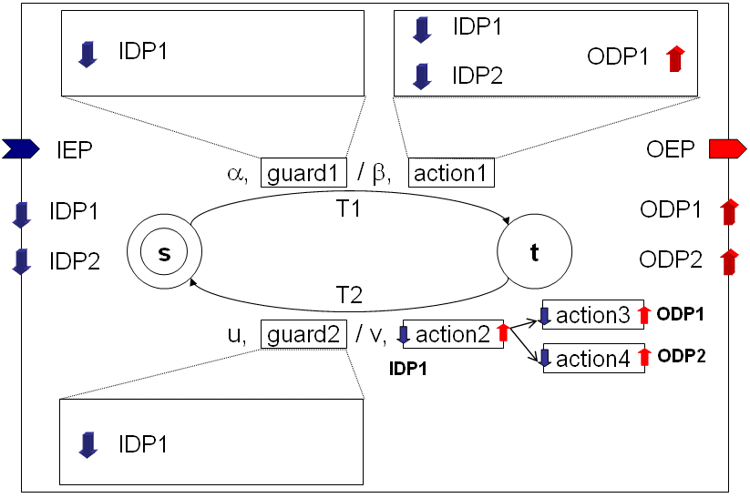
Figure 3: A simple SEFSM component model
A SEFSM component is an FSM-based model. We use a simple component model shown in Figure 3 as an example to explain the structure and the behavior of SEFSM components. The component communicates with other components through ports, including a single input event port (IEP), an output event port (OEP), two input data ports (IDP1 and IDP2) and two output data ports (ODP1 and ODP2). As shown in the figure, the component includes an FSM, where transitions are labeled with a trigger event, a guard, an output event and set of actions. Guards and actions are computational functions within the component and receive their input data through input data ports. The execution of an action (a function) may produce new data, while the execution of a guard only returns a Boolean value for the true or false evaluation. Therefore, an action has a set of output data ports while a guard does not.
Whenever a component receives an event, it consumes the event and evaluates which transition is enabled. A transition is enabled if its source state is the current state, its trigger event matches the incoming event and the evaluation of its guard function returns true. For safety reasons, EFSM intentionally prohibits non-determinism. If the enabled transition is labeled with an output event and actions, the component generates the output event and executes the actions, which may produce output data. The new created event and data are stored in the corresponding event and data ports. Note that the output event and output data of a component should be delivered to destination components simultaneously and the delivery process takes logical (per the synchrony assumption) zero time.
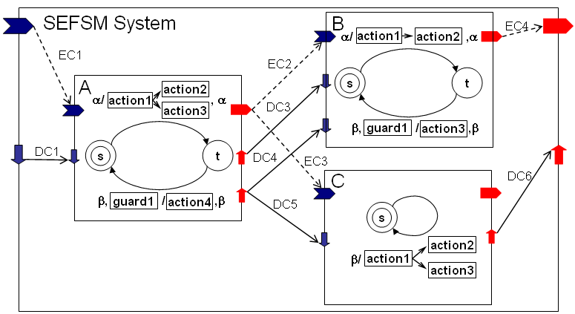
Figure 4: A simple SEFSM system model
A SEFSM system consists of a set of components, event channels, data channels, an input and an output event port, and a set of input and output data ports. To illustrate this, Figure 4 presents a simple SEFSM system model, including three components A, B and C. Event channels are represented as dashed lines and data channels are shown as concrete lines. Multiple event channels can be connected to the same output event port, but only one event channel can be connected to an input event port. This restriction eliminates the possibility that a component may receive multiple events during one reaction. A data port is also not allowed to receive multiple data since this will cause a non-deterministic decision on which data is to be used in the computation. However, data channels are allowed to merge, if at most one of the merged data channels actually delivers data in one computation cycle. When a component is activated by an event, some of its input data ports may be empty. However, those data ports that provide data for evaluating guards and for executing actions must contain data.
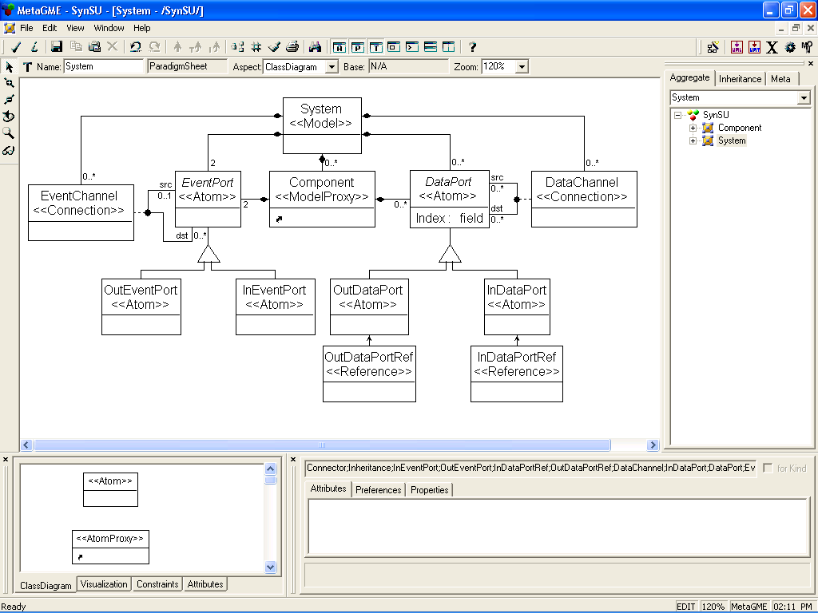
Figure 5: A paradigm in the SEFSM metamodel defining the system structure

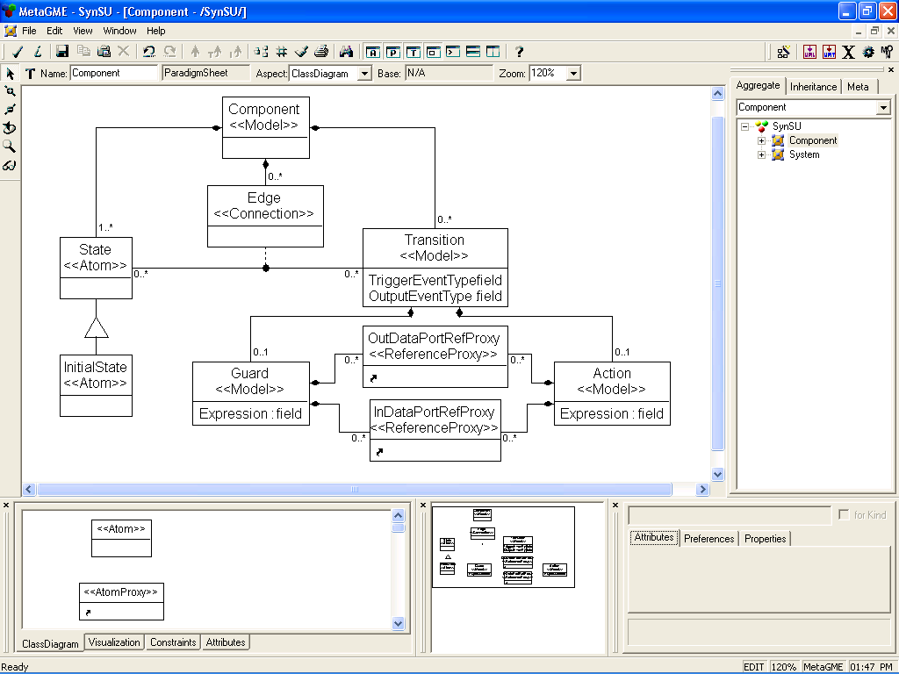
Figure 6: A paradigm in the SEFSM metamodel defining the component structure

Figures 5 and 6 show the abstract syntax metamodel of SEFSM in MetaGME [12] (a UML/OCL-based metamodeling language). The metamodel in Figure 5 and 6 define the sub-language for representing the system-level structure and for the component-level structure, respectively. A set of OCL (Object Constraint Language) constraints [12] are added to the SEFSM metamodel to specify well-formedness rules for the models. For example, the OCL constrain,
self.connectedAs("dst")->size()=1 and self.connectedAs("src")->size()=1,
is attached to the Transition class in Figure 6, which claims a transition object should have a single source state and a single destination state.
It is easy to see that the abstract syntax metamodels and the textual description of the behavior are insufficient for the precise understanding of the semantics of SEFSM. For example, the metamodel specification does not reveal the complex interdependency between the event flow and the data flow structure of the components that both define partial orders for the evaluation of guards and execution of actions.

Primary Semantic Units Used
In the following section we briefly elaborate the primary semantic units FSM-SU and SDF-SU that we use to compose the semantics of, first SEFSM Components, and then SEFSM Systems. We describe these semantics unit here directly with their AsmL specifications as they are readable and executable.

Specification of FSM-SU
The Finite State Machine Semantic Unit (FSM-SU) defines the behavioral semantics of the basic non-deterministic FSM, which can be mathematically defined as a 5-tuple
where
- S is a finite set of states;
- Σ is an input alphabet, consisting of a set of input symbols;
- Δ is an output alphabet, consisting of a set of output symbols;
- $σ⊆S×\sum{}Δ×S$is a set of transitions;
- $s_{0}∈S$ denotes the initial state.
The specification contains two parts as we mentioned earlier: an Abstract Data Model A_{FSM-SU} and Operations and Transformation Rules R_{FSM-SU} on the data structures defined in A. The AsmL abstract class FSM prescribes the top-level structure of a FSM, including a set of states, transitions, relationships between states and transitions, and relationships between transitions and event types. All the abstract members of FSM are further specified by a concrete FSM, which is an instance of the Abstract State Model.
structure Event
eventType as String
class State
id as String
initial as Boolean
var active as Boolean = false
class Transition
id as String

abstract class FSM
id as String
abstract property states as Set of State
get
abstract property transitions as Set of Transition
get
abstract property outTransitions as Map of <State, Set of Transition>
get
abstract property dstState as Map of <Transition, State>
get
abstract property triggerEventType as Map of <Transition, String>
get
abstract property outputEventType as Map of <Transition, String>
get
The operational semantics of FSM-SU is specified as a set of AsmL rules. Two rules that are important in behavioral composition are briefly explained here. The rule Run specifies the top-level system reaction of a FSM when it receives an event. Note that the ‘?’ modifier after Event means the return from the Run rule may be either an event or an AsmL null value.
abstract class FSM
React (e as Event) as Event?
step
let CS as State = GetCurrentState ()
step
let enabledTs as Set of Transition = {t | t in outTransitions (CS) where e.eventType = triggerEventType(t)}
step
if Size (enabledTs) = 1 then
choose t in enabledTs
step
CS.active := false
step
dstState(t).active := true
step
if t in me.outputEventType then
return Event(outputEventType(t))
else
return null
else
if Size(enabledTs) > 1 then
error ("NON-DETERMINISM ERROR!")
else
return null
The operational rule GetCurrentState returns the current state of a FSM. A state is considered as the current state if it is active. If a FSM has multiple active states, the rule reports an error. If it has no active state, the initial state is considered as the current state.
abstract class FSM
GetCurrentState () as State
step
let currents = {s | s in me.states where s.active}
step
if Size (currents) > 1 then
error ("FSM has multiple active states")
else
if Size (currents) = 0 then
return GetInitialState ()
else
choose s in currents
return s

Synchronous Dataflow Semantic Unit
The Synchronous Dataflow Semantic Unit (SDF-SU) defines the behavioral semantics of the Synchronous Dataflow (SDF) that can be mathematically expressed as a 5-tuple
$$\left\langle N,P,C,f_{\text{ip}},f_{\text{op}}\right\rangle$$
where:
- N is a finite set of nodes;
- P is a finite set of ports;
- $C⊆P×P$ is a finite set of channels;
- $f_{\text{ip}}:N→2^{P}$ is a map that assigns each node to its input ports;
- $f_{\text{op}}:N→2^{P}$ is a map that assigns each node to its output ports.
The AsmL specification of the Abstract Data Model A_{SDF-SU} is shown below. Token is defined as an AsmL structure to package data. (We included only three types of data (integer, double and Boolean) in the specification using the AsmL construct case.) Port and Channel are defined as first-class types. The Boolean attribute exist of a port indicates whether the port has a valid data token. When all the input ports of a node have valid data tokens, the node is enabled to fire. In the semantics specification, Fire is an abstract function. A concrete node will override the abstract function Fire with a computational function. The AsmL abstract class SDF captures the top-level structure of a model. The abstract property inputPorts contains a sequence of the SDF model’s input ports that does not belong to any internal nodes. The abstract property outputPorts expresses the similar meaning.
structure Value
case IntValue
v as Integer
case DoubleValue
v as Double
case BoolValue
v as Boolean

//Data Token, it may contain a value or a null data
structure Token
value as Value?

//Data Port, when exist is true, the port has an effective data token
class Port
id as String
var token as Token = Token (null)
var exist as Boolean = false
class Channel
id as String
srcPort as Port
dstPort as Port

abstract class Node
id as String
abstract property inputPorts as Seq of Port
get
abstract property outputPorts as Seq of Port
get
abstract Fire ()
abstract class SDF
id as String
abstract property nodes as Set of Node
get
abstract property channels as Set of Channel
get
abstract property inputPorts as Seq of Port
get
abstract property outputPorts as Seq of Port
get
Two key operational rules in the R_{SDF-SU} specification are explained here. The operational rule GetEnabledNode returns a set of nodes in a SDF model that are ready to fire.
abstract class SDF
GetEnabledNodes () as Set of Node
return {n | n in me.nodes where forall p in n.inputPorts where p.exist}
The operational rule Fire specifies the behaviors that a SDF model takes to fire a node. The AsmL construct require asserts that the node to fire should be an enabled one. The Fire function of Node is defined by the node itself. However, it should consume the data tokens in all input ports of the node and produce data tokens to all output ports of the node. Otherwise, the rule will report an error. If an output port of the node is connected with multiple channels, the data token in it will be duplicated and propagated along all these channels. If the destination port of a channel already has an effective data token, the rule will report a non-deterministic error since it does not know which data token should be placed in the port.
abstract class SDF
Fire (n as Node)
require n in me.GetEnabledNodes ()
step
n.Fire ()
step
if exists p in n.inputPorts where p.exist then
error ("After the firing of a node, all input tokens should be consumed by the node.")
step
if exists p in n.outputPorts where not p.exist then
error ("After the firing of a node, each of its output port should have one effective token.")
step
forall c in me.channels where c.srcPort in n.outputPorts
if c.dstPort.exist then
error ("Non-deterministic error.")
else
c.dstPort.token := c.srcPort.token
c.dstPort.exist := true
c.srcPort.exist := false
The operational rule Run specifies the steps it takes to execute a set of nodes. This rule can be considered as a composition interface for SDF-SU. In the beginning, some of the nodes in the set may not be enabled, but they are supposed to be enabled by the execution of already enabled ones. The rule non-deterministically chooses an enabled node from the set and fires it. The execution of a node consumes the data tokens in all input ports of the node and produce them to all output ports as well. The operational rule Fire executes the node and propagates data tokens produced by the execution of the node through all the connected channels. The rule Run reports error if there are no enabled nodes in the set while the set is not empty.
abstract class SDF
Run (ns as Set of Node)
step while Size(ns) <> 0
choose n in ns where n in GetEnabledNodes ()
remove n from ns
Fire (n)
ifnone
error ("Some Nodes are not enabled to fire.")

Compositional Semantics Specification for SEFSM Components
As we described before, the behavior of individual SEFSM components can be divided into two different behavioral aspects: the FSM-based behavior expressing reactions to events and the SDF-based behavior controlling the execution of computational functions (actions and guards). In this section, we formally specify the behavioral semantics of SEFSM components as composition of two primary semantic units: FSM-SU and SDF-SU. The compositional semantics specification consists of two parts: (1) an Abstract Data Model defining the structural composition <A_{C}, A_{FSM-SU}, A_{SDF-SU}, g₁, g₂>, where g₁: A_{C} → A_{FSM-SU} , and g₂: A_{C} → A_{SDF-SU} are structural relation maps; and (2) Operations and Transformation Rules specifying the behavioral composition <R_{C} , R_{FSM-SU} , R_{SDF-SU} > .

Structural Composition
The structural composition defines mapping from elements in the Abstract Data Model of the composed semantic unit to elements in the FSM-SU model and those in the SDF-SU model. Figure 7 shows the role of the FSM-SU and SDF-SU in the SEFSM component model by restructuring the example in Figure 3. In the modified structure, the FSM model controls the event-related behaviors, while the SDF model takes charge of the data-related computations. Comparing Figure 3 and 7, we can find that the overall structure of the FSM model closely matches that of the original SEFSM component, except for events, guards and actions. The trigger events and the output events in the FSM model are renamed. The guards and actions are represented as nodes in the SDF model. The relationships between the FSM model and the SDF model are specified by two maps: GuardMap and ActionMap. In this section, we only briefly explain how these two maps help to relate the FSM model with the SDF model. More details will be introduced in the following behavioral composition section.
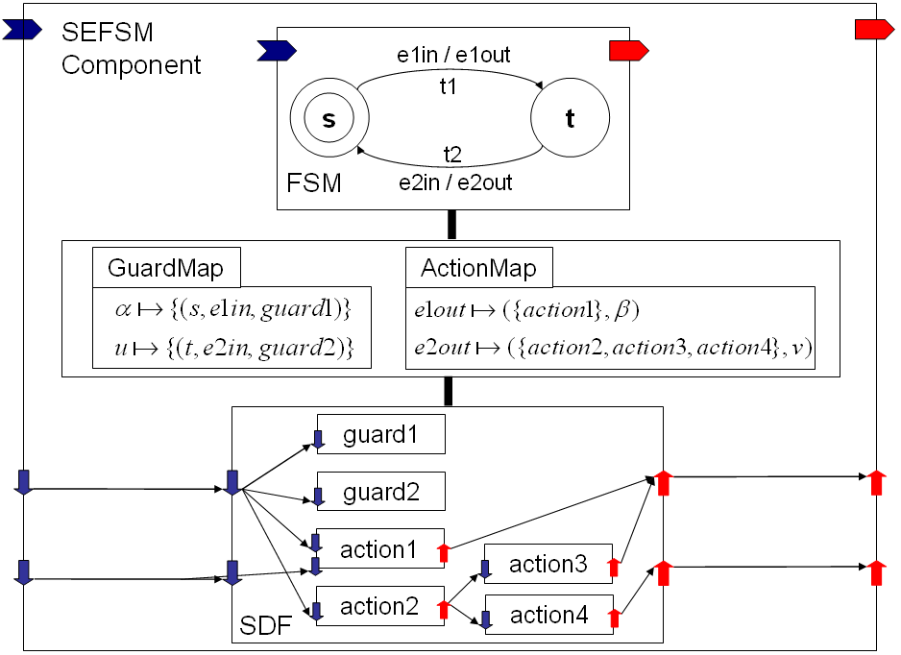
Figure 7: A compositional structure of the SEFSM component originally shown in Figure 3
The new compositional structure is built in a way that each transition in the original component is decomposed into three parts: a transition in the FSM model, a node representing the guard and a node representing the action in the SDF model. In the original component, a transition can be unambiguously located by the combination of the source state, the trigger event, and the guard. In the compositional structure, the information can be expressed by a 3-tuple (s, e, n), where s refers a state in the FSM model; e is a local trigger event in the FSM model; and n represents a node in the SDF model. When a component receives an event, this event is a global event and will not be directly forwarded to the FSM model. The GuardMap maps this global event to a set of 3-tuples, each tuple referring to a transition in the original component whose trigger event matches this global event. Using the example in Figure 3 again, the event α is the trigger event only for the transition T1. In the compositional structure as shown in Figure 7, the T1 transition is decomposed into the t1 transition in the FSM model, whose source state is s and trigger event is e1in, and the guard1 and action1 node in the SDF model. As a result, GuardMap assigns the event α to the set {(s, e1in, guard1)}.
class EventPort
id as String
var evnt as Event = Event ("")
var exist as Boolean = false
abstract class Component
id as String
abstract property inPort as EventPort
get
abstract property outPort as EventPort
get
abstract property GuardMap as Map of <String, Set of(String, String, Node?)>
get
abstract property ActionMap as Map of <String, (Set of Node, String?)>
get
abstract property fsm as FSM
get
abstract property sdf as SDF
get

Behavioral Composition
In essence, the behavioral composition specifies the rules R_{C}, which is akin to a component-level controller (or scheduler) that orchestrates the executions and interactions of the FSM model and the SDF model.
The execution of a transition in the original (SEFSM) component can be decomposed into a three-step process: (1) the evaluation of the guard functions for all outgoing transitions from the current state as nodes in the SDF model; (2) selection of an enabled transition in the FSM model; and (3) the execution of actions of the transition as nodes in the SDF model. The three steps are related to each other by the maps GuardMap and ActionMap. The output event produced by the execution of a transition in the FSM model is a local event. ActionMap maps it to a 2-tuple ({n}, e), where {n} refers to a set of nodes (actions) in the SDF model and e refers to a global output event that will be propagated out of the component. For instance, the execution of the t2 transition of the FSM model in Figure 7 generates a local event e2out. As the t2 transition corresponds to the T2 transition in the original component (Figure 3), which is attached with actions: action2, action3 and action4, and an output event v, the ActionMap maps the local event e1out to a 2-tuple ({action2, action3, action4}, v) accordingly.
The rules verbalized above are specified in AsmL as Operation and Transition Rules. The operational rule Run of Component specifies the top-level component operations as a sequence of updates. The AsmL construct require asserts that the component’s input event port must have a valid event. The rule first consumes the event in the port and checks whether this event triggers further updates in the component. If the event does, the rule MapToLocalInputEvent returns the corresponding local event used to trigger the FSM model; if not, a null value is returned and the reaction is completed. If a valid local event is returned, it activates the FSM model. The reaction of the FSM model returns a local output event. If the SEFSM component produces an output event in this reaction, the rule MapToGlobalOutputEvent maps the local event to the global output even, which is then stored in the output port of the component.
abstract class Component
React ()
require inPort.exist
step
inPort.exist := false
let localEvent as Event? = MapToLocalInputEvent (inPort.evnt)
step
if localEvent <> null then
step
let e as Event? = fsm.React (localEvent)
step
let globalEvent as Event? = MapToGlobalOutputEvent (e)
step
if globalEvent <> null then
outPort.evnt := globalEvent
outPort.exist := true
The operational rule MapToLocalInputEvent maps the global event received by the component to a local event that activates the FSM model, and evaluates guards placed as nodes in the SDF model. First, GuardMap maps the received event to a set of 3-tuples {(s, e, n)}, each of which can locate a transition in the component whose trigger event matches this event. A transition is an enabled one if it satisfies all the three conditions: (1) its trigger event matches the received event; (2) its source state is the current state; (3) the evaluation of its guard is true.
GuardMap returns the set of all tuples that satisfy the first condition. Then, the rule enquires the current state of the FSM model using the operational rule GetCurrentState and removes those tuples whose first element does not refer to the current state. The third element in the tuple refers to a node in the SDF which is actually a guard in the component. If this element is a null value, it indicates the corresponding guard is default true. The rule evaluates the guards and removes those tuples whose guard evaluation returns false. All the remaining tuples in the set then refer to the current enabled transitions in the component. If the size of this set is larger than 1, the rule reports a non-deterministic error; if the set is empty, the rule returns a null value due to no enabled transition; otherwise, the rule creates and returns a local input event to activate the FSM model.
abstract class Component
MapToLocalInputEvent (e as Event) as Event?
step
if e.eventType in GuardMap then
step
var enabledTransitions as Set of (String, String, Node?) = GuardMap (e.eventType)
step
let s as State = fsm.GetCurrentState ()
step
forall g in enabledTransitions
if g.First <> s.id then
remove g from enabledTransitions
step
forall g in enabledTransitions where g.Third <> null
if not EvaluateGuard (g.Third) then
remove g from enabledTransitions
step
if Size(enabledSet) > 1 then
error ("NON-DETERMINISM ERROR")
else
if Size (enabledSet) = 1 then
choose g in enabledSet
return Event (g.Second)
else
return null
else
return null
The operational rule MapToGlobalOutputEvent maps a local event produced by the FSM model to a global output event, and executes actions placed as nodes in the SDF model. First, ActionMap maps a local output event to a 2-tuple ({n}, e). If the component needs to execute actions in this reaction, {n} refers to a set of nodes in the SDF model which encapsulates those actions. If the component produces an output event in this reaction, e is the type of that output event; otherwise, e is a null value. If e is not a null value, the rule creates and returns the corresponding global output event; otherwise, the rule returns a null value.
abstract class Component
MapToGlobalOutputEvent (e as Event) as Event?
step
if e.eventType in ActionMap then
step
let actionTuple as (Set of Node, String?) = ActionMap(e.eventType)
step
sdf.Run (actionTuple.First)
step
if actionTuple.Second <> null then
return Event (actionTuple.Second)
else
return null
The semantics of SEFSM components is defined as the composition of the two semantic units: FSM-SU and SDF-SU. We observe that this behavioral semantics specification is not limited to the SEFSM components. It actually specifies the semantics of a common behavioral category that captures the reactive computation behaviors. Therefore, we can consider the compositional semantics specification of SEFSM components as a new derived semantic unit, called Action Automaton Semantic Unit (AA-SU). We leverage this AA-SU in the following section to compositionally specify the semantics of SEFSM Systems.

Compositional Semantics Specification for SEFSM Systems
A SEFSM system is composed of a set of components, which communicate with each other through event channels and data channels. The semantics of SEFSM systems is defined as the composition of AA-SU and SDF-SU. The compositional semantics specification for SEFSM includes: (1) an Abstract Data Model defining the structural composition <A_{C}, A_{AA-SU}, A_{SDF-SU}, g₁, g₂>, where g₁: A_{C} → A_{AA-SU}, and g₂: A_{C} → A_{SDF-SU} are structural relation maps; and (2) Operations and Transformation Rules specifying the behavioral composition <R_{C} , R_{AA-SU} , R_{SDF-SU} >.

Structural Composition
The structural composition defines the communication relationships among components, in terms of an event flow and a data flow. The event flow is constructed using event channels connecting the input/output event ports. The data flow is created by connecting the input/output data ports with data channels. As it is shown in Figure 8, we reuse again the SDF-SU semantic unit to model the interaction semantics for the data flow. It is important to note that although the SDF sections of the individual components together with the SDF interaction among the components are integrated into a single SDF model, this is still a model system. Due to the integration with the FSM sections, always only a subset of the SDF nodes is involved in a reaction of the SEFSM system. We chose not to declare the event flow interaction model as a semantic unit. Figure 8 presents the role of the AA-SU, SDF-SU and the event flow interactions in the SEFSM system model by restructuring the example in Figure 4. This new structure gives a much clearer expression for the control dependency among components and the data dependency among computational functions (actions and guards).
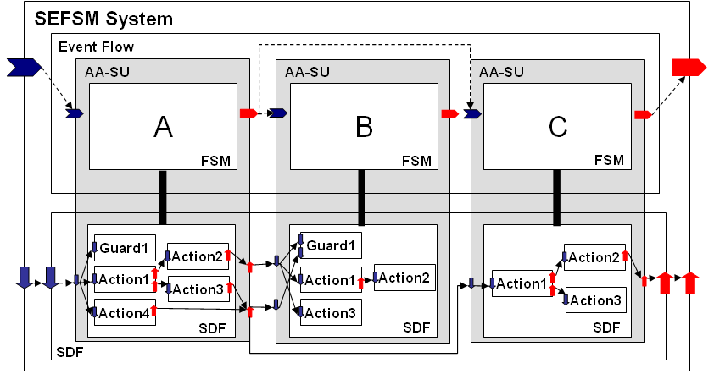
Figure 8: The compositional structure of the SEFSM system originally shown in Figure 4
The AsmL abstract class System captures the top-level structure of a SEFSM system. The abstract property components is a set that holds all components in a system. The control dependency among components is expressed by a set of event channels contained in the abstract property channels. The data dependency among computational functions is described by a SDF model. Each component has a reference to this SDF model. The relationship between a component and the SDF model is defined by the AA-SU (e.g. the abstract property GuardMap and ActionMap in the class Component).
class EventChannel
id as String
srcPort as EventPort
dstPort as EventPort

abstract class System
abstract property inPort as EventPort
get
abstract property outPort as EventPort
get
abstract property components as Set of Component
get
abstract property channels as Set of EventChannel
get
abstract property sdf as SDF
get

Behavioral Composition
The behavioral composition of the SEFSM system defines a system-level controller (or scheduler) that controls the executions and the order of the executions of components, event channels and the SDF model. The operational rule Runt of System specifies the top-level system operations as a sequence of updates. The AsmL construct require asserts that the system should have a valid input event. Firstly, the rule propagates the event in the input event port of the system along all the connected event channels to the destination ports that refer to the input event ports of components. In the meantime, the operational rule Initialize, defined in the SDF-SU, propagates the data tokens in the input ports of the SDF model along the connected data channels to the destination ports that refer to the input ports of nodes. The next step is to keep running until the operations inside the step cause no further state updates in the ASM (fixpoint). The stopping condition for an AsmL fixpoint loop is met if no non-trivial updates have been made in the step. Updates that occur to variables declared in ASMs that nested inside this loop are not considered. An update is considered non-trivial if the new value is different from the old value.
Within the loop, the rule first activates all the components who receive an event. The reactions of these components then produce new events. If new events are produced, the rule propagates them to the destination components and continues the loop; otherwise, the loop is stopped. Finally, the rule ClearPorts defined in SDF-SU is utilized to clear all the input data ports in the SDF model because the SEFSM system does not store the data generated in the last computation cycle.
abstract class System
Run ()
require inPort.exist
step
forall c in me.channels where c.srcPort.exist
c.dstPort.evnt := c.srcPort.evnt
c.srcPort.exist := false
c.dstPort.exist := true
ddf.Initialize ()
step until fixpoint
step
forall comp in me.components where comp.inPort.exist
comp.React ()
step
forall c in me.channels where c.srcPort.exist
c.dstPort.evnt := c.srcPort.evnt
c.dstPort.exist := true
c.srcPort.exist := false
step
ddf.ClearPorts ()
This behavioral semantics is actually not unique to SEFSM. Rather, it captures the common behavior of event-driven synchronous reactive systems. Therefore, we can consider the compositional semantics specification of SEFSM as a new derived semantic unit for event-driven synchronous reactive systems. Details of the specification clearly demonstrates the similarities between the semantics of SEFSM and well known event-driven synchronous reactive systems and opens up the possibility of utilizing a rich variety of analytical techniques that have been developed in that domain.

Conclusion
Compositional specification of semantics is a necessary step for making DSMLs semantically sound and practical. The proposed approach builds on a large body of work on ASMs [6] [7], semantics of composition [11] [21] [22], and on our earlier work on semantic anchoring [10] [13] [14]. The lessons learned from the case study on specifying the semantics of SEFSM are the followings:
- Systematic composition of the semantics from simpler units was extremely helpful in building the specification.
- The explicit semantics revealed complex interactions among the constituents. For example, the composition of event and data flow on the system level (Section 7) may result in deadlocks, whenever the partial order of actions defined by the event flow cannot be composed with the partial order of actions defined by the data flow. Consequently, the deadlock-freeness of models needs to be verified by system level analysis (similarly to causality analysis in some of the synchronous languages).
- The AsmL simulator tool has been very useful for exploring the behavior of the defined language using its “reference semantics”. Since AsmL Data Models are automatically generated from SEFSM models (built in GME), experimentation is quite simple.
As a future step we will continue the construction of a library of primary semantic units and will move toward increased automation in the compositional specification of semantics.

References
- The Eclipse Project. http://www.eclipse.org/.
- Jack Greenfield, Keith Short. Software Factories: Assembling Applications with Patterns, Models, Frameworks, and Tools. Wiley Pub., 2004.
- Object Management Group. UMLTM Profile for Modeling and Analysis of Real-Time and Embedded systems. realtime/05-02-06.
- Susan Graph, Ileana Ober. How Useful is the UML profile SPT Without Semantics? In Workshop on the usage of the UML profile for Scheduling, Performance and Time (SIVOES '04), Toronto Canada, 2004.
- MoBIES Group. HSIF semantics. The University of Pennsylvania, 2002.
- E. Boerger, A. Cavarra and E. Riccobene. On formalizing UML state machines using ASMs. Information Science and Technology, vol. 46, pages 287-292, 2004.
- E. Boerger and R. Staerk. Abstract State Machines: A Method for HighLevel System Design and Analysis. Springer, 2003.
- G. Karsai, J. Sztipanovits, A. Ledeczi, and T. Bapty. Modelintegrated development of embedded software. Proceedings of the IEEE, volume 91, pages 145–164, 2003.
- A. Sangiovanni-Vincentelli. Defining platform-based design. EEDesign of EETimes, February 2002.
- Chen K., Sztipanovits J., Abdelwahed S. A Semantic Unit for Timed Automata Based Modeling Languages. In Proceedings of RTAS’06, pages. 347-360, 2006.
- Johan Eker, Jörn W. Janneck, Edward A. Lee, Jie Liu, Xiaojun Liu, Jozsef Ludvig, Stephen Neuendorffer, Sonia Sachs, Yuhong Xiong. Taming Heterogeneity The Ptolemy Approach. Proceedings of the IEEE, volume 91, pages 127–144, 2003.
- MIC Tool Suite. http://www.escherinstitute.org/Plone/tools/suites/mic.
- Chen K., Sztipanovits J., Neema S., Emerson M., Abdelwahed S. Toward a Semantic Anchoring Infrastructure for Domain-Specific Modeling Languages, In Proceedings of the Fifth ACM International Conference on Embedded Software (EMSOFT’05), pages 35-44, Jersey City, New Jersey, September 19, 2005.
- Chen K., Sztipanovits J., Abdelwahed S., Jackson E. Semantic Anchoring with Model Transformations. In Proceedings of European Conference on Model Driven Architecture -Foundations and Applications (ECMDA-FA), Nuremberg, Germany, November 7, 2005. Lecture Notes in Computer Science, vol. 3748. pages 115-129, Springer-Verlag, 2005.
- The Abstract State Machine Language. www.research.microsoft.com/fse/asml.
- Kim G. Larsen, Paul Pettersson and Wang Yi. UPPAAL in a Nutshell. Springer International Journal of Software Tools for Technology Transfer 1(1+2), 1997.
- Marius Bozga, Susanne Graf, Ileana Ober, Iulian Ober and Joseph Sifakis. Tools and Applications II: The IF Toolset. In Flavio Corradinni and Marco Bernanrdo,editors, Proceedings of SFM'04 (Bertinoro, Italy), Lecture Notes in Computer Science, vol. 3185, Springer-Verlag, 2004.
- The Generic Modeling Environment. http://www.isis.vanderbilt.edu/Projects/gme/.
- The Graph Rewriting and Transformation. www.isis.vanderbilt.edu/Projects/mobies.
- The Semantic Anchoring Tool Suite. www.isis.vanderbilt.edu/SAT.
- Gossler, G., Sifakis, J. Composition for Component-Based Modeling. Science of Computer Programming, vol. 55, 2005.
- Balarin, F., Lavagno, L., Passerone, C., Sangiovanni-Vincentelli, A. L., Sgroi, M., and Watanabe, Y. Modeling and Designing Heterogeneous Systems. In Concurrency and Hardware Design, Advances in Petri Nets Lecture Notes In Computer Science, vol. 2549, pages 228-273, Springer-Verlag, London, 2002.
- S. Birla, S. Wang, S. Neema, and T. Saxena. Addressing cross-tool semantic ambiguities in behavior modeling for vehicle motion control. In Automotive Software Workshop 2006, San Diego, CA, April 2006.

